Fitbit: adding new participant to study
- Go to the Fitbit SDK website: https://dev.fitbit.com/login
- Login with created Fitbit credentials for patient
- Register a new app and configure to be the same as image file “Setup for fitbit apps.png”
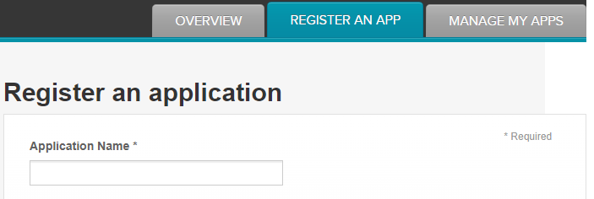
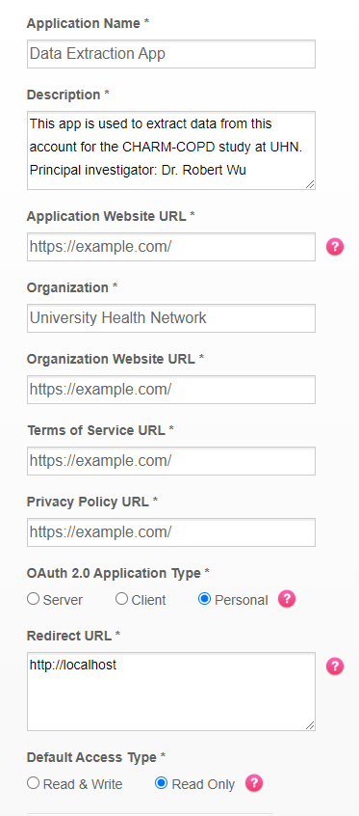
The application name and description will need to be changed for the specific study.

Once this is set up:
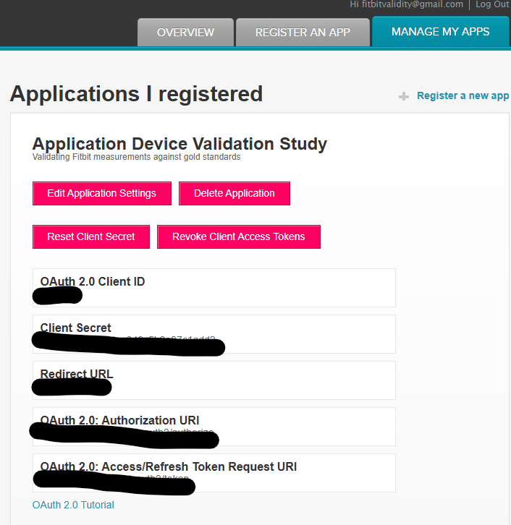

Copy paste the client ID here: https://www.fitbit.com/oauth2/authorize?response_type=token&client_id=[COPY PASTE]&redirect_uri=https://localhost&scope=activity%20heartrate%20location%20nutrition%20oxygen_saturation%20profile%20respiratory_rate%20settings%20sleep%20social%20temperature%20weight&expires_in=31536000
Copy paste the URL into browser
Should get an error message (this is normal). Save the URL (should be localhost/#access_token=[access token]&user_id=[user ID]
Use the access token + user ID to run the script

